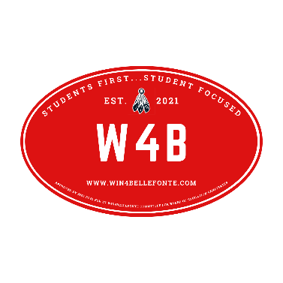 | WIN 4 BELLEFONTE  Executive Committee  2025 School Board Candidate Application  Welcome to the application for the W4B selection process that provides coordinated support to selected candidates. Please complete the form below. You may attach it as a document and email it to win4bellefonte@gmail.com or send it through US mail to: Win4Bellefonte, 604 Buffalo Run Road, Bellefonte, PA 16823.
Your Name
Email
Address
Voting District
Phone number
- Volunteer/Community Service

- Special skills that would help your run for the Board as well as help you make decisions as a Board Member.

- In your opinion, what are the top three issues that need to be addressed at BASD?

- What are your thoughts about how BASD should operate fiscally?

- Being part of the W4B team requires a solid commitment attending W4B meetings, fund raising participation, and presence at events that promote selected candidates. What is your commitment?
- Anything else you would like us to know?

Thank you for your application to be part of the W4B team. We will acknowledge it’s receipt by email.

